UNIT 8 FOOD AND CULTURE
OUTLINE

1 Language Development
1.1 Countable and uncountable nouns
1.2 Grammar for writing:
- Subject – verb agreement
- Determiners: a, an, and some
2 Vocabulary
Vocabulary for food and drink
(e.g. potatoes, _________, _________, _________, _________ )
3 Critical thinking
3.1 Use pie charts
3.2 Brainstorm
3.3 Analyze notes
3.4 Make notes
4 Input
4.1 Listening
4.1.1 Listening for numbers
4.1.2 Predicting content using visuals
4.1.3 Understanding key vocabulary
4.1.4 Listening for detail

4.1.5 Listening for main ideas
4.2 Reading
4.2.1 Skimming
4.2.2 Previewing
4.2.3 Understanding key vocabulary
4.2.4 Scanning to find information
4.2.5 Reading for detail
5 Output
5.1 Speaking task:
Report the results of a survey.
5.2 Academic writing skills:
Spelling
5.3 Writing task:
Write about food in your country for a student website.

EXERCISES
1 Listen and complete the sentences with the numbers in the box.
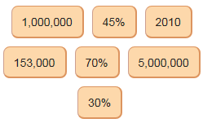

- Singapore is a small country. It's an island in fact. And there are about ____5000000__ people living there.
- We buy food from many countries, but __45%____ of all our food comes from Malaysia and __30%____ comes from China.
- ___70%___ of all the food that we buy are fruit or vegetables.
- We eat a lot of fish too - ___153000___ tonnes in 2010.
- But you can see here that in ___2010___, chicken was more popular than fish.
- Over __1000000____ tonnes of food came to Singapore in 2005.

2 Look at the pie charts. Choose True or False.
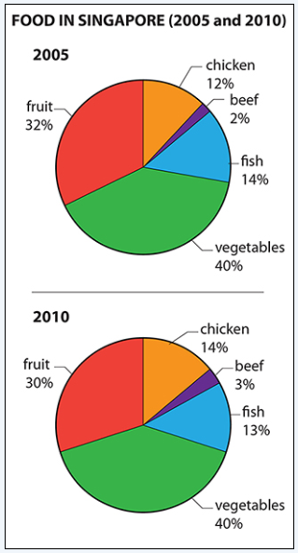
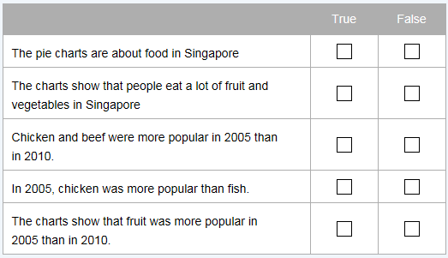
3 Reading
Coffee
Millions of people start their day with a cup of coffee. It is popular all over the world. Coffee has a special smell and flavour. But what is coffee and where does it come from? And how long has it been popular?
Coffee is made from the roasted seeds of the Coffea arabica plant. Farmers grow this plant in over 70 countries in South America, Southeast Asia, India and Africa. Coffee is very important for these countries to grow and sell.
Some people say the history of coffee begins in Africa. They say people in Ethiopia were the first to drink coffee. Others say coffee farming began in southern Arabia. We know people drank coffee in fifteenth-century Yemen. From here, coffee spread through the Arab World and on to Turkey. In Turkey, coffee is called kahve. This word comes from the Arabic word qahwah. From Turkey, coffee went on to Italy and through Europe to Britain. The English word coffee comes from the Italian caffe.
Coffee is served in many different ways. Some people add milk or cream. This is called white coffee. Other people prefer coffee without milk or cream. This is called black coffee. Some people add sugar or sweetener. You can also drink coffee cold. This is iced coffee. Many people drink coffee for breakfast in the morning. Others enjoy a coffee break at work in the middle of the morning. People also drink coffee after a meal, especially in restaurants.
- Read the text. Write true (T) or false (F) next to the statements.
- Coffee is made from the roasted eggs of Coffea Arabica, a small, forest animal.
- Farmers in South America, Southeast Asia, India and Africa grow coffee.
- The early history of coffee started in Europe.
- The Turkish word kahve comes from the English word coffee.
- Black coffee hasn't got milk in it.
- Read the text again and answer the questions.
- How many countries grow coffee?
_______________________________________________
- Where did coffee drinking start?
_______________________________________________
- How did coffee spread from Yemen to Britain?
_______________________________________________ .
- What is white coffee?
_______________________________________________
- When do people drink coffee?
_______________________________________________

- Read the definitions. Write the words from the box next to the correct definitions. You do not need every word.
potatoes dates milk honey onion chillies spices butter almonds yoghurt water coconut

- These are round vegetables. They grow underground. Chips, French fries and crisps are made from them. ______ potatoes ______
- This is a white liquid. It comes from cows. ____ milk ________
- This is sweet and yellow. Bees make it. ____ honey ________
- This is a large fruit. It’s brown and hairy on the outside, white on the inside and contains a clear liquid called milk. _____ coconut _______
- This is a thick white liquid. It’s made from milk and sometimes people put fruit or honey in it. ______ yoghurt ______
- This is a vegetable with a strong smell and flavour. It’s round and has a brown or red skin. It’s white inside. _____ onion _______
- These are made from plants. People use them in cooking to give special flavour to food. Cinnamon, ginger and cloves are all examples. _____ spices _______
- This is a clear liquid, without colour or taste. It is necessary for plant and animal life. It falls from the sky as rain. ______ water ______
- These are small nuts with hard shells. ______ almonds ______
- These are a sweet fruit. They grow on palm trees. _____ dates _______

- Write the words from the box in the correct columns.
potatoes dates milk honey onion spices butter yoghurt water chillies

countable nouns | uncountable nouns

- Writing task: Write about food in your country for a student website.
- Brainstorm the food in two popular dishes from your country.

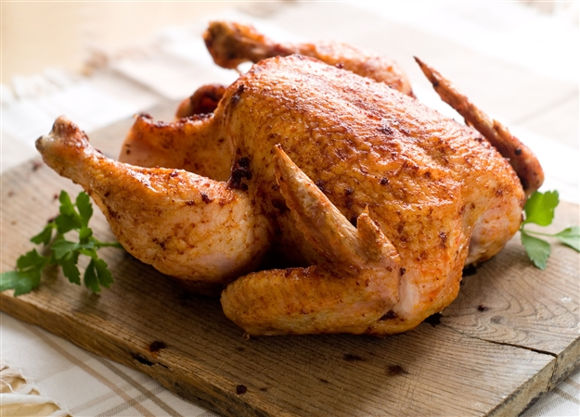

- Look at your notes. Write C next to countable nouns and UC next to uncountable nouns. Use a dictionary to help you.

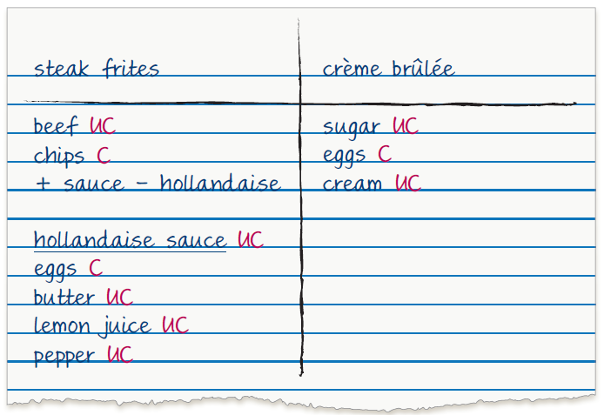

- Look at the brainstorming notes you have made. Write answers that are true for your dishes in the gaps.

________________________ (which?) cuisine
At a ________________________ (which?) restaurant, you find many different kinds of ________________________ (what kinds of food?).
________________________ (what kind of dishes?) are very popular.
________________________ (which?) food is also famous for (what kind of food or what kind of dishes?).
___________________________________________________________
___________________________________________________________
___________________________________________________________
___________________________________________________________
___________________________________________________________
___________________________________________________________
___________________________________________________________
___________________________________________________________
___________________________________________________________
- Write sentences about two popular dishes in your country. Add them to your text above.

7 Speaking task: Report the results of a survey.
For this task, work with your classmates before the speaking class.
Step 1: Write your names in the questionnaire below.
Step 2: Choose a topic for your survey from the box. Add it to the questionnaire.
fast food
sweet food
traditional food

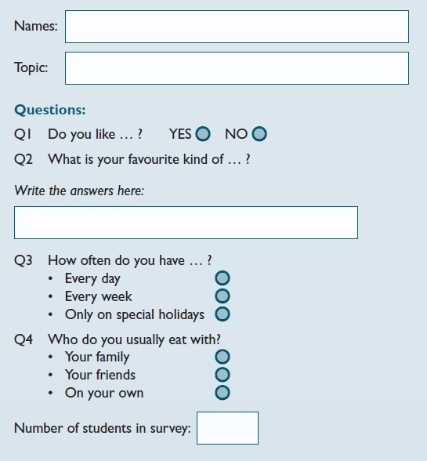

Step 3: Interview at least three students in your class. And the more number of them are recommended.
• Ask questions 1–4 about your topic.
• Write the answers on the questionnaire.
• Write the number of students in your survey.

Step 4: Write your results in the table below. For question 2, write the kind of food and the number of people.
e.g.

Q1 | Yes: ______ No: ______
Q2
Q3 | every day: ______  every week: ______  special holidays: ______
Q4 | with family: ______  with friends: ______  on your own: ______

Step 5: Use the results to make a pie chart for each question.

KEYS
KEY
1
1) 5,000,000 2) 45%, 30% 3) 70% 4) 153,000 5) 2010 6)1,000,000
[Audio script]:
Hello, everybody! My name's Jade. I'm going to tell you about food in my country, Singapore. I think this is a good topic, because we do not grow a lot of food in Singapore. Singapore is a small country. It's an island in fact. And there are about 5 million people living there. So we don't have any big farms to grow our own food.
OK, so where does our food come from? Well, we buy food from other countries. We buy food from many countries, but 45% of all our food comes from Malaysia and 30% comes from China.
And which kinds of food are popular in Singapore? Well, you can see here that my charts show two different years – 2005 and 2010.
We buy a lot of fruit and vegetables. 70% of all the food that we buy is fruit or vegetables. So I think people in Singapore are healthy! But we also buy meat from other countries.
Chicken is very popular in Singapore. In 2010, people in Singapore ate 169,000 tonnes of chicken! We eat a lot of fish too – 153,000 tonnes in 2010. Singapore is an island, so of course it is easy to buy fish from Malaysia or Indonesia. There are a lot of different fish dishes in Singapore. For example, fish head curry is a very famous dish.
But you can see here that in 2010, chicken was more popular than fish. So I think chicken is going to be more popular now.
So how much food do we buy every year? Well, over 1 million tonnes of food came to Singapore in 2005. Today, it is more – last year more than 1,250,000 tonnes of food came from other countries.
So, are there any questions?

2 T T F F T

3
- F T F F T
- 1 Over 70
2 Ethiopia or southern Arabia
3 Coffee spread through the Arab world to Turkey, Italy, and then through Europe to Britain.
- Coffee with milk or cream
- In the morning for breakfast, during a coffee break in the middle of the morning, after a meal

4
1)-5) potatoes, milk, honey, coconut, yoghurt, onion, spices, water, almonds, dates.
6)-10) onion, spices, water, almonds, dateas

5
countable nouns | uncountable nouns
potatoes,  dates,  onion,  chillies,  spices | milk,  honey,  butter,  yoghurt,  water

6-7 As subjective tasks, there are no suggested answers for them.

Appendix: Worksheet for the speaking class.

以下是听说直播课的部分讲义，建议你提前预习，做好听课准备。
Speaking task: Report the results of a survey.
 | Student's name  ______ | ______ | ______ | ______
topic
Q1 | Yes: ______  No: ______ | Yes: ______  No: ______ | Yes: ______  No: ______ | Yes: ______  No: ______
Q2
Q3 | every day: ______  every week: ______  special holidays: ______ | every day: ______  every week: ______  special holidays: ______ | every day: ______  every week: ______  special holidays: ______ | every day: ______  every week: ______  special holidays: ______
Q4 | with family: ______  with friends: ______  on your own: ______ | with family: ______  with friends: ______  on your own: ______ | with family: ______  with friends: ______  on your own: ______ | with family: ______  with friends: ______  on your own: ______

